Stereo panning
Introduces the StereoPannerNode
The Web Audio API defaults to working with stereo audio. Though it can handle a variety of different multichannel formats as well as mono, most nodes default to up-mixing or down-mixing inputs, where necessary, to two channel audio streams. Stereo is also the dominant format for produced music. Here, we introduce the principles, notation and theory behind stereo audio. We then discuss the StereoPannerNode, which uses level-based panning to position an audio stream anywhere in the stereo field.
Two code examples are provided. First, a simple use of the StereoPannerNode, showing a minimal implementation. Then a stereo enhancer or stereo widener effect, which takes a stereo input stream and re-represents it as mid and side rather than left and right components. The relative strength of these components can be varied to narrow or widen the audio stream's use of the stereo field.

Theory
Previously, we described a digital audio signal as a discrete series of values, sampled uniformly in time. But the listener has two ears, and hears the sound differently in each ear depending on the location of the source. Stereo audio files encode two signals, or channels, for listening over headphones or loudspeakers, so that sources can be localized. Furthermore, spatial audio reproduction systems will often use a large number of loudspeakers, recreating an entire sound scene, thus requiring more channels.
For reproduction of spatial audio via multiple loudspeakers, we should first consider how we localize sound sources. Consider a listener hearing the same content coming from two different locations, and at different times and levels. Under the right conditions, this will be perceived as a single sound source, but emanating from a location between the two original locations. This fundamental aspect of sound perception is a key element in many spatial audio rendering techniques.

Panorama
Suppose we have two loudspeakers in different locations. Then the apparent position of a source can be changed just by giving the same source signal to both loudspeakers, but at different relative levels. When a camera is rotated to depict a panorama, or wide angle view, this is known as panning. Panning in audio is derived from this, and describes the use of level adjustment to move a virtual sound source. During mixing, this panning is often accomplished separately for each sound source, giving a panorama of virtual source positions in the space spanned by the loudspeakers.
Consider a standard stereo layout. The listener is placed in a central position as depicted in Figure 16.1, and we suppose the loudspeakers are placed on a unit circle around the listener. In this figure, there is a 90 degree angle between loudspeakers, so 45º angle formed by each loudspeaker with the frontal direction. φ is the angle of the apparent source position, known as the azimuth angle. $s=(s_{x},s_{y})=(\cos{ϕ},\sin{ϕ})$ defines the unit length vector pointing towards the source, and L=(L_{x}, L_{y}) and R=(R_{x}, R_{y}) are the vectors pointing to the loudspeaker locations. These loudspeaker vectors are found just from geometry.
$$L=(cos(-45),sin(-45))=(1/\sqrt{2},-1/\sqrt{2}) \\ R=(cos(45),sin(45))=(1/\sqrt{2},1/\sqrt{2})$$
The virtual source location s can be constructed by applying gains, g_{L} and g_{R}, to the loudspeaker locations, L and R,
$$s_{x}=g_{L}L_{x}+g_{R}R_{x}=\left(g_{L}+g_{R}\right)/\sqrt{2} \\ s_{y}=g_{L}L_{y}+g_{R}R_{y}=\left({-g}_{L}+g_{R}\right)/\sqrt{2}$$
So we can solve this to find the gains applied to each loudspeaker,
$$g_{L}=(\cos{ϕ}-\sin{ϕ})/\sqrt{2} \\ g_{R}=(\cos{ϕ}+\sin{ϕ})/\sqrt{2}$$ | (16.1)
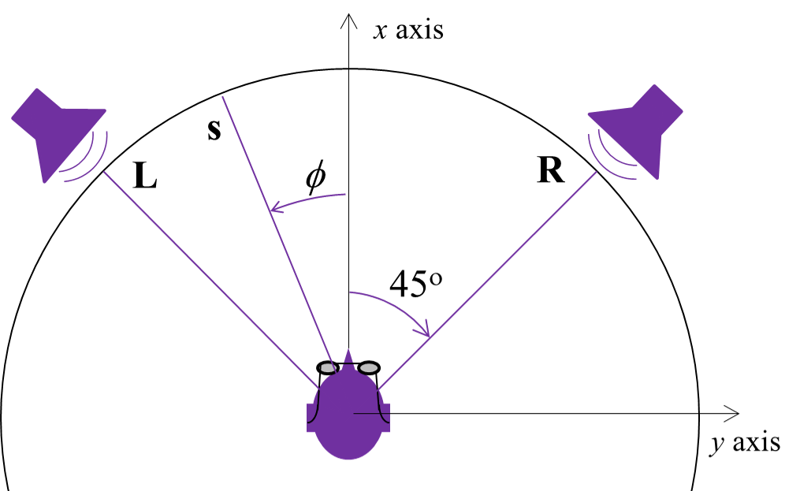
Figure 16.1. Listener and loudspeakers configuration for placing a sound source using level difference.
Equation (16.1) is a panning law, describing how gains are applied to each loudspeaker in order to reposition a source. This approach can be put in matrix form, for arbitrary loudspeaker angles (and even for virtual placement in higher dimensions using more than 2 active loudspeakers), see (Pulkki, 1997) and (Reiss & McPherson, 2014).
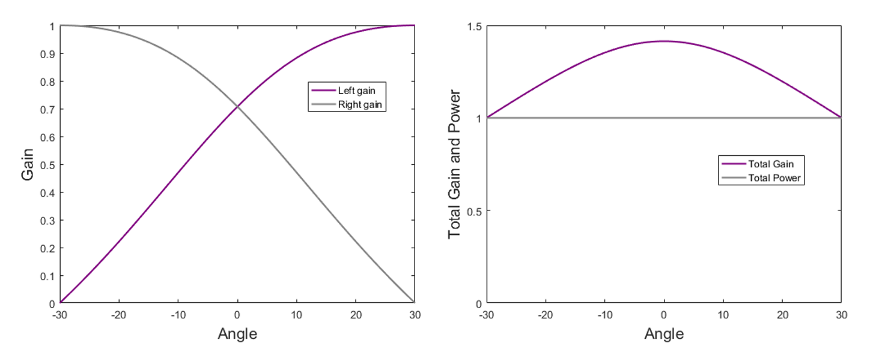
Figure 16.2. Constant power panning for two channels. On the left is the gain for each channel, and on the right is the total power and total gain.
Figure 16.2 depicts the gain and power for constant power panning as a function of the azimuth angle φ. Though total power $\sqrt{{g_{L}}^{2}+{g_{R}}^{2}}$ is constant, total gain $g_{L}+g_{R}$ varies as a function of azimuth angle, reaching its maximum when the source is positioned equidistant from both loudspeakers.
From Equation (16.1), we can also find the perceived angle for the source as a function of the gains for our loudspeaker placement.
$$tanϕ=\frac{g_{R}-g_{L}}{g_{R}+g_{L}}$$
The general form of this for any loudspeaker angles is known as the tangent law.
Figure 16.3 shows this perceived azimuth angle as a function of the level difference between the applied gains.
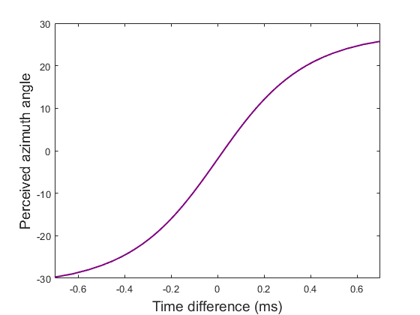
Figure 16.3. Perceived azimuth angle as a function of level difference.
Note that this approach is much preferred over crossfade panning, where the apparent position of the sound source is shifted by linearly interpolating the amplitude between the two extremes of hard left and hard right. Crossfading produces a “hole” in the middle due to the reduced power when not scaling.

StereoPannerNode
The StereoPannerNode represents a simple stereo panner node that can be used to positions an incoming audio stream left or right in the stereo field. The input of this node is mono (1 channel) or stereo (2 channels) and cannot be increased. Connections from nodes with more channels will be down-mixed to stereo. The output of this node is stereo (2 channels) and cannot be configured.
The panner node has just one audio-rate parameter, pan, which determines the panning position and ranges from -1 (full left pan) and 1 (full right pan). The same effect can be achieved using particular settings of the PannerNode (see 0), but the StereoPannerNode is far simpler.
The exact implementation of the panning algorithm is given in the Web Audio API specification, but mathematically it can be represented as follows. Let p represent panning position, x represent the input for a mono source, x_{L} and x_{R} represent input for a stereo source, and y_{L} and y_{R} represent the left and right channel output. Then we have two cases, either mono or stereo input.
For mono input;
$$y_{L}=x cos((p+1)π/4) \\ y_{R}=x sin((p+1)π/4)$$
Returning to Equation (16.1), we can use trigonometric identities to rewrite the gains.
$$g_{L}=(\cos{ϕ}-\sin{ϕ})/\sqrt{2}=cos(ϕ+π/4) \\ g_{R}=(\cos{ϕ}+\sin{ϕ})/\sqrt{2}=sin(ϕ+π/4)$$
Hence monaural panning in the Web Audio API is just application of the panning law, Equation (16.1), with $p=4ϕ/π$.
For stereo input;
if p ≤0,
$$y_{L}=x_{L}+x_{R} sin(|p|π/2) \\ y_{R}=x_{R} cos(|p|π/2)$$
if p >0,
$$y_{L}=x_{L}cos(|p|π/2) \\ y_{R}=x_{R} +x_{L} sin(|p|π/2)$$
Here, p<0 leaves the left channel unchanged but pushes the right channel towards the left, and p>0 leaves the right channel unchanged but pushes the left channel towards the right. This is shown in Figure 16.1, which plots the final panning position of a source as a function of the applied pan value, for different initial panning positions.
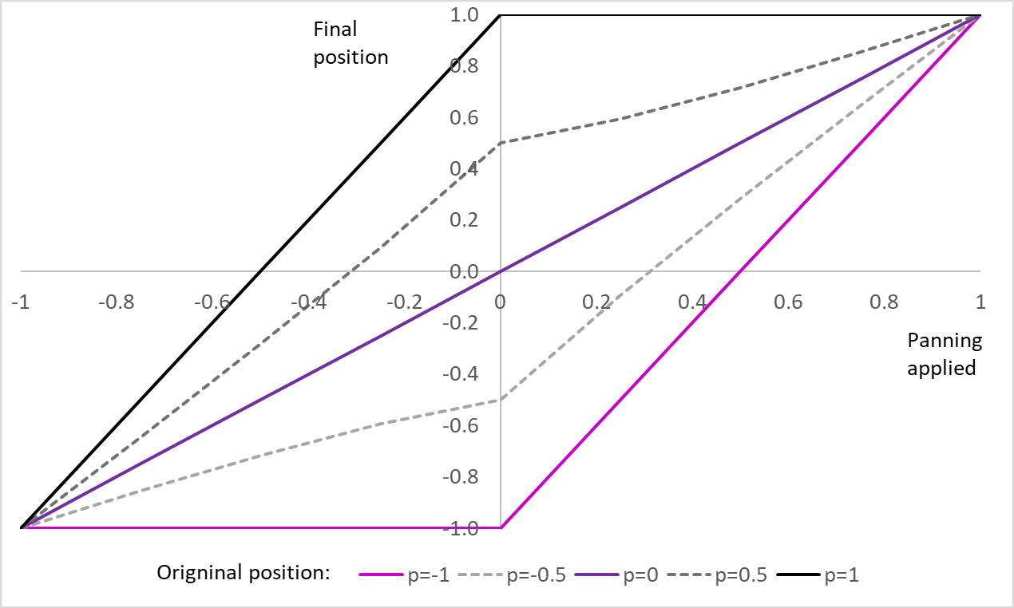
Figure 16.4. How panning of a stereo source affects its panning position. Final panning position versus the panning applied is plotted for 5 stereo sources with original positions between left (p=-1) and right speakers (p=+1)
Note that power is preserved for a mono source, ${y_{L}}^{2}+{y_{R}}^{2}=x^{2}$. But power is not preserved for a stereo source, ${y_{L}}^{2}+{y_{L}}^{2}={x_{L}}^{2}+2x_{L}x_{R}+{x_{R}}^{2}≠{x_{L}}^{2}+{x_{R}}^{2}$.

Example – Stereo panning
Code example 16.1 is a simple example of panning. An oscillator’s panning position is controlled by the user, allowing the perceived position of the source to vary between the extremes of coming from the left speaker (pan=-1) to coming from the right speaker (pan=+1). You should observe that the perceived level stays roughly constant as the slider is moved back and forth.
<input type='range' min=-1 max=1 step='any' id='panning'>
<script>
let context= new AudioContext()
let source = context.createOscillator()
source.start()
let panNode = context.createStereoPanner()
panning.oninput = function() {
context.resume()
panNode.pan.value = this.value
}
source.connect(panNode).connect(context.destination)
</script>

Code example 16.1. stereoPanning.html, a simple panning example.

Example - Stereo enhancer
A stereo enhancer (also known as stereo widener) takes a stereo input and transforms it into a mid-side representation. That is, rather than representing a stereo signal by the strength in the left channel and the strength in the right channel, we represent it by how much of it is in the middle and how much is off to the sides. Once in a mid-side representation, the relative strengths of these two components can be changed before it is converted back to stereo.
To convert back and forth between left and right channel representation, L and R, and mid-side representation, M and S, we use the following relationships,
$$\begin{matrix}M = (L+R)/√2 \\ S = (L-R)/ √2\end{matrix} and \begin{matrix}L = (M+S)/√2 \\ R = (M-S)/ √2\end{matrix}$$
So a mono signal would have content only in the mid channel. A signal coming only from the left channel, would have equal strength in the mid and side channels. This seems counterintuitive at first since the signal is only on one side. But the more extreme case is when the left and right channels have opposite sign. In that case, the signal is considered to be only on the side channel since left and right cancel out in the middle.
Stereo enhancement is performed by changing the relative strengths of these channels with a stereo width parameter W. The stereo width ranges from -1 (mono) to 0 (unchanged) to +1 (maximally panned), When the width is -1, there is no signal in the side channel, and the mid channel results in an equal left and right channel output. When the width is +1, the stereo width is fully enhanced and there is no signal in the mid channel. This is similar to how a single channel can be positioned in stereo by the StereoPannerNode with a pan parameter ranging from -1 (left) to 0 (centered) to +1 (right).
There are various implementations of stereo width, but one of the most straightforward is to implement it just like the panning law, but instead operating on mid and side channels. So after converting to a mid-side representation, the Width parameter is applied as;
$$\begin{matrix}M_{new} = M cos((W+1)π/4) \\ S_{new} =S sin((W+1)π/4)\end{matrix}$$
Code example 16.2 demonstrates a stereo enhancer.
<input type='range' min=-1 max=1 value=0 step='any' id='width'>
<script>
let context= new AudioContext()
let source = new AudioBufferSourceNode(context,{loop:true})
let sourceL = context.createGain()
let sourceR = context.createGain()
fetch('Stereo speech.wav')
.then(response => response.arrayBuffer())
.then(buffer => context.decodeAudioData(buffer))
.then(data => source.buffer = data)
var splitter = context.createChannelSplitter(2)
source.connect(splitter)
splitter.connect(sourceL,0)
splitter.connect(sourceR,1)
source.start()
let Mid = new GainNode(context,{gain:Math.sqrt(0.5)})
let Side = new GainNode(context,{gain:Math.sqrt(0.5)})
let minusSourceR = new GainNode(context,{gain:-1})
sourceL.connect(Mid)
sourceR.connect(Mid)
sourceL.connect(Side)
sourceR.connect(minusSourceR).connect(Side)
let gainMid = new GainNode(context)
let gainSide = new GainNode(context)
Mid.connect(gainMid)
Side.connect(gainSide)
let outputL = new GainNode(context,{gain:Math.sqrt(0.5)})
let outputR = new GainNode(context,{gain:Math.sqrt(0.5)})
let minusGainSide = new GainNode(context,{gain:-1})
gainMid.connect(outputL)
gainSide.connect(outputL)
gainMid.connect(outputR)
gainSide.connect(minusGainSide).connect(outputR)
width.oninput = function() {
context.resume()
gainMid.gain.value = Math.cos((parseFloat(width.value)+1)*Math.PI/4)
gainSide.gain.value = Math.sin((parseFloat(width.value)+1)*Math.PI/4)
}
let merger = context.createChannelMerger(2)
outputL.connect(merger,0,0)
outputR.connect(merger,0,1)
merger.connect(context.destination)
</script>

Code example 16.2. StereoEnhancer.html, a stereo width enhancer.
We first load a stereo file into an AudioBufferSourceNode. The file is a short stereo recording of a symphony orchestra warming up; this form of stereo enhancement would not work with a mono recording since there would be no side information to enhance.
We then follow the steps outlined above for converting to and from a mid-side representation. We use a ChannelSplitterNode to split the left and right channels into two streams. Next we convert this into mid-side representation. The mid channel is created by summing these two streams, by connected them both to the input of a gain node. The side channel is created by inverting the right channel (connecting it to a gain node with gain equal to minus one) and summing that with the left channel.
These two streams, giving the mid-side representation, are then connected to GainNodes, whose gain parameters are determined by the stereo width parameter. Finally, the mid and side channels, with this stereo enhancement, are converted back to left and right, and merged into a stereo signal.
The effect of stereo enhancement on the position of a source is shown in Figure 16.5.
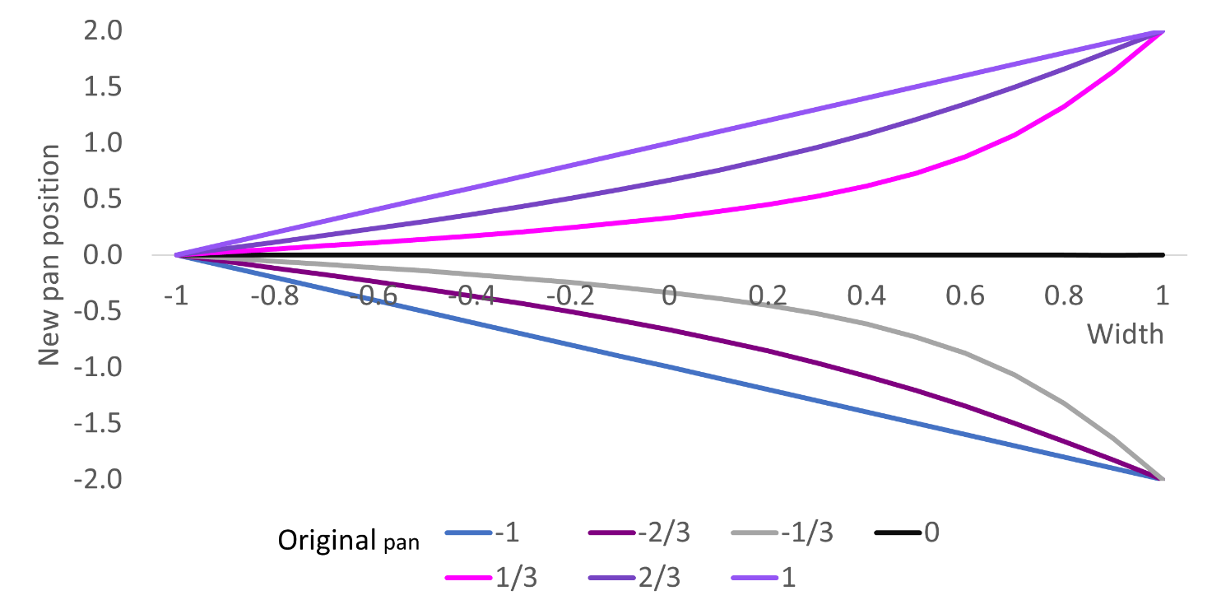
Figure 16.5. The effect of stereo enhancement on the panning position of a source. Width less than 1 moves a source towards the center, width greater than 1 moves it away from the center. Panning positions above 1 or below -1 indicate a change of sign between left and right channels.
This approach, and many other stereo enhancement techniques, are slightly problematic since the output signal power depends on the initial panning position of the stereo source. In Chapter 19, we show how audio worklets can be used to create a constant power stereo widener.

